**Arc flash**

According to the relevant standard from the National Fire Protection Association, Arc Flash is a “dangerous condition associated with the release of energy caused by an electrical arc.” The term "arc flash hazard" is used to describe the risk facing people who works on living parts.The analysis of Arc Flash Hazard defines the procedures that limit the damage of electric arcs on persons.An electric arc occurs due to loss of insulation between two conductive object at sufficient voltage.The short circuit power is high as we go nearer to high electrical power equipment (transformers, generators, switchgears,…etc). The energy released by the arc due to the fault causes rise in surrounding temperature and pressure. This puts nearby equipment under mechanical and thermal stress and can result in serious nearby injuries.

**Electrical arcs and their dangerous effects on people**

There are four phases the arc formation passes through:-

* Compression stage: In this stage, overheating of The air volume where the arc is created took place due to the release of energy. The remaining air volume in the cubicle is heated by convection and radiation. Initially, each zone has temperature and pressure different from other zones.
* Expansion phase: As soon as the internal pressure rises, a hole opens and the superheated air begins to escape. The pressure reaches it’s peak value and starts to decrease when hot air is released.
* Emission phase: due to continous release of energy by the arc, nearly all the overheated air is forced out due to constant overpressure;
* Thermal phase: after the release of the air, the temperature inside the switchgear nears the temperature of the electrical arc. This final phase lasts until the arc is quenched, when all the metals and the insulating materials coming into contact undergo erosion with production of gas, fumes and molten material.

**Burns caused by arc flash**

The high temperature of the gases produced by the arc and the emission of incandescent metal particles can cause severe burns. Flames can cause all kinds of burns, including carbonization:

Red-hot solid metal fragment can cause third-degree burns, superheated steam can cause burns similar to hot liquids, radiant heat generally causes minor burns.

**System Earthing**

Earthing means connecting the neutral point of a star connected transformer to ground. Grounding makes it easier for leakage of overcurrent. The short-circuit current of a device flows to earth with zero potential. this Protect your system and equipment from damage. the galvanised iron is commonly used for the earthing.

**Types of earthing system:**

* Solidly earthed system
* Unearthed and high impedence system
* Resistance earthed system
* Peterson-Coil Earthed System

**Low voltage earthing Systems**

* TT
* IT
* TN – TN-C, TN-S, TN-C-S

These three types are defined by IEC 60364

the first letter, 'T' denotes that the starting point of the source is solidly connected to earth, which is usually at a location very near to the winding. letter 'I' denote that the starting point and the winding are isolated from earth. The start point is usually connected to an inductive impedance or resistance. Capacitive impedance is not used. the second letter, ‘T’ denotes that the consumer has solidly earthed and doesn't depend on the source earthing method. 'N' denotes that a conductor with low impedence is taken from the earth connection at the source and routed directly to the consumer for the specific purpose of earthing the consuming equipment. 'S' denotes that the neutral conductor routed from the source is separate from the protective earthing conductor, that is also routed from the source. This refers that five conductors need to be routed for a three-phase consumer. 'C' denotes that the neutral conductor and the protective earthing conductor are the same conductor. That means that four conductors need to be routed for a three-phase consumer.

**TT Earthing System**

In this type of Earthing System, connection to the supply source is directly connected to ground(earth) & load end or installation metalwork is also directly connected to earth. Therefore, in case of overhead line, the mass of the earth will be the return path for the line. The neutral and earthing conductor must be separated through the installation because the power distributor provides only the supply neutral or protective conductor for the connection to the consumer.

**IT Earthing System**

Power distribution systems have no or only a high impedance ground connection. A fundamental feature of an IT grounding system is the ability of the system to continue to operate without interruption in the event of a phase-to-ground fault. Such an error is called a "first error". Therefore normal grounding protection is ineffective for this system and this type is not intended to power loads. IT grounding systems are used in power distribution systems such as substations and generators.

**TN-S Earthing System**

In this system, ground and neutral are separated throughout the distribution system. The protective conductor is the metal cover of the cable that provides the installation. All accessible conductive parts of the installation are connected to this protective conductor or via the main earthing terminal of the installation.

**TN-C Earthing System**

Neutral and protective earths are combined into single conductor for the entire system. All exposed and conductive parts of equipment are connected to PEN conductors. According to 8(4) of the Electrical Safety, Quality and Continuity Regulations 2002, "Consumers shall not combine neutral and protective functions on a single conductor in customer installations."

**TN-C-S Earthing System**

Neutral and protective earth are combined into a single conductor into one part of the system. This type of grounding is also called multiple protective grounding. Her PEN conductors in utility systems are earthed at two or more points on him and may require earth electrodes at or near consumer installations. All exposed conductive parts of the installation are connected to the PEN conductors through the main earth and neutral terminals and these terminals are interconnected.

**Main protection devices**

**Residual current devices(RCDs)**

RCDs are protection devices used in electric installations. They are designed to quickly trip the electric circuits in order to protect the user of the device from any serious harm or injury because of electrical shock. No doubt that RCDs saved many lives throughout the years.RCDs are designed to ensure that the current flowing through the line terminal is equal to that flowing through the neutral terminal. If the current is not the same, The RCD will disconnect the supply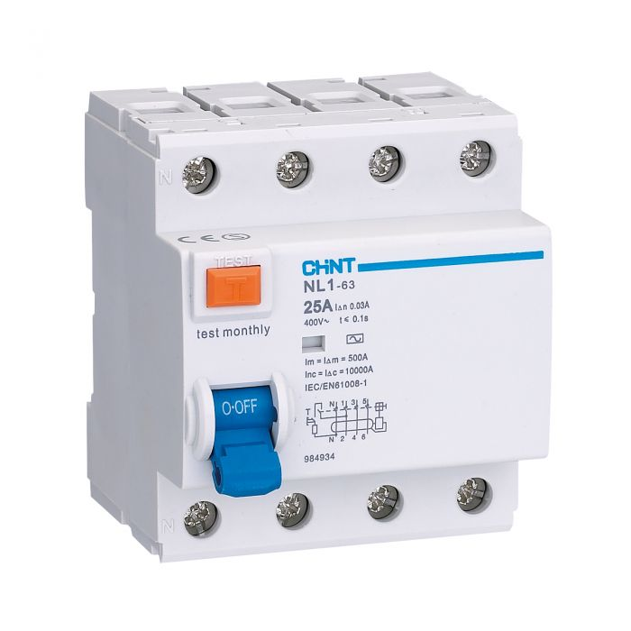

**Earth Leakage Circuit Breake(ELCB)**

ELCB is a safety device used in both commercial and residential electrical installations that prevent electric shocks using a high earth impedance. This device can detect and protect any leakage of installation

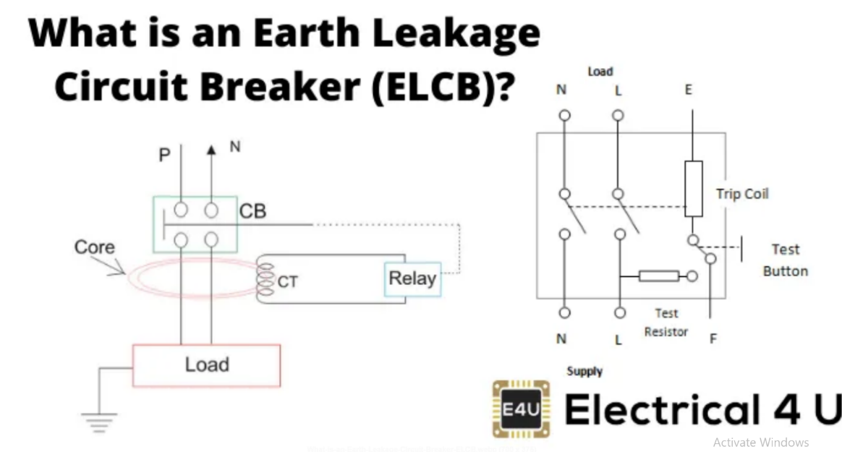

**References**

[‘Handbook of Electrical Engineering: For Practitioners In The Oil, Gas And Petrochemical Industry’ by Alan L. Sheldrake](https://books.google.co.in/books?id=QjB_DAAAQBAJ&pg=PA363&lpg=PA363&dq=T+denotes+that+the+consumer+is+solidly+earthed+independently+of+the+source+earthing+method.&source=bl&ots=eF8rmQh_uj&sig=ACfU3U2tFC2bMTlE0OgB3eCDE6WBqH1Mkw&hl=en&sa=X&ved=2ahUKEwjx1OPE4_3oAhXk4zgGHfcCBG8Q6AEwCXoECAwQAQ#v=onepage&q=T%20denotes%20that%20the%20consumer%20is%20solidly%20earthed%20independently%20of%20the%20source%20earthing%20method.&f=false)